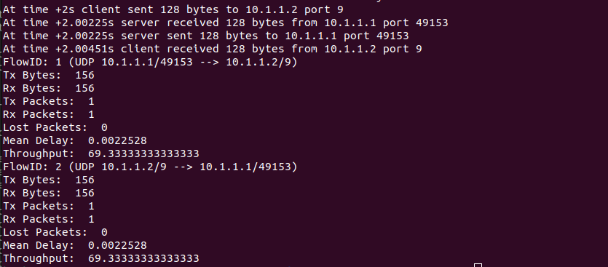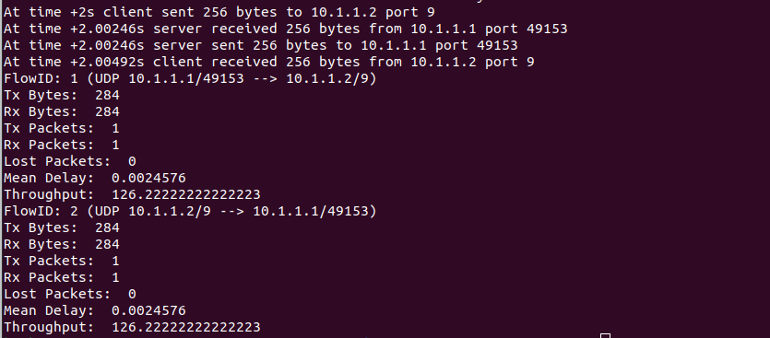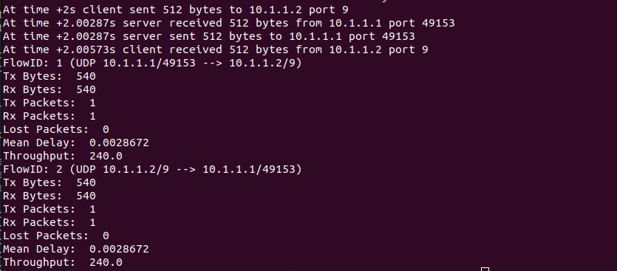

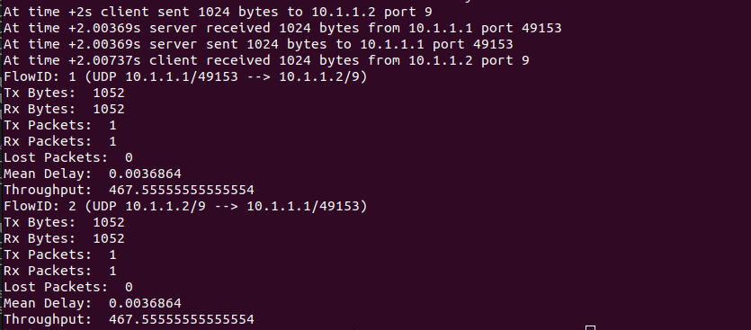
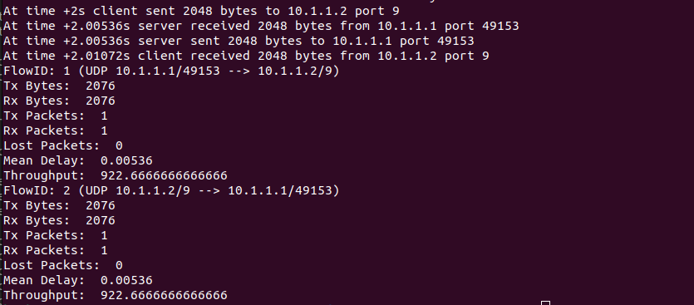

Graph (throughput(y) vs data size(x)):

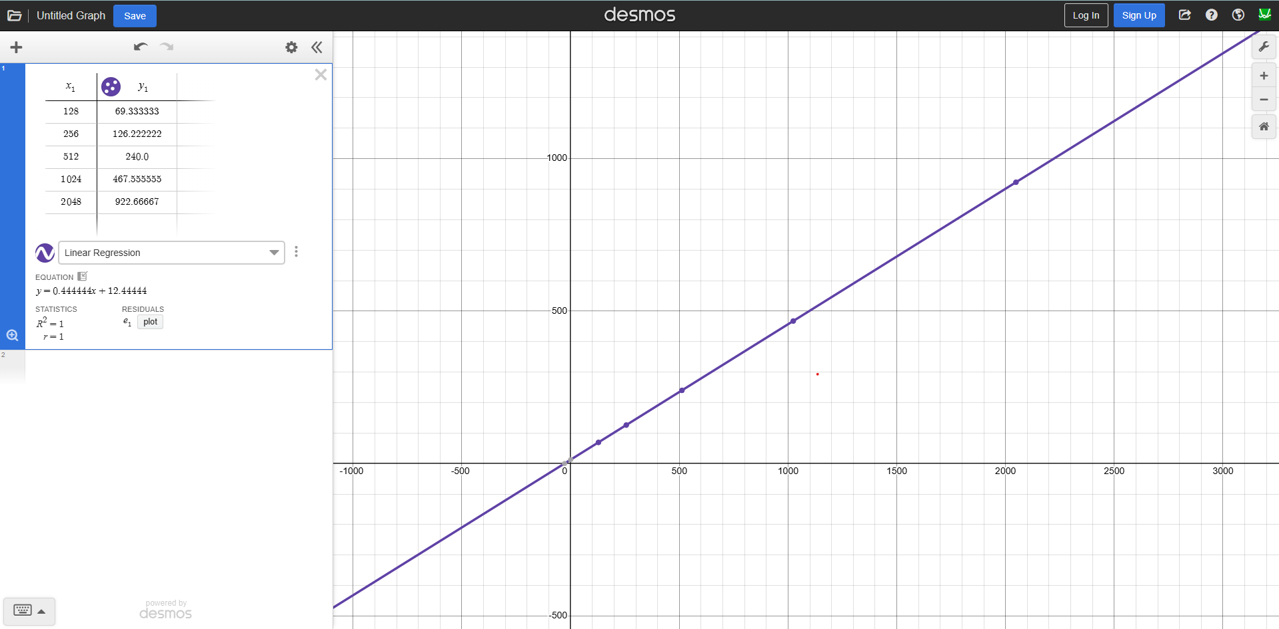

This graph shows that as the packet size (values along the x-axis) gets bigger, the throughput(values along the y-axis) also increases in a smooth and steady way. It suggests that larger packets help improve performance, with very little slowdown or data loss along the way.

